**Pearly Gates Cemetery and Crematorium**

**Table**

**of Contents**

**Title Page#**

1. Use Case Diagram
   1. List of all use cases………………………. 6
   2. Use case diagram for the System………. 7
2. Use case descriptions…………………………. 8-10
3. Class diagram…………………….……………. 11
4. Sequence diagram……………………………. 12-15
5. System architecture and deployment strategy
   1. System architecture………………………. 16-17
   2. Deployment strategy……………………… 18-19
6. User Interface…………………………………... 20-21
7. Meeting Minutes…………………………………22-31
8. References……………………………………… 32
9. Tool Used………………………………………. 32
10. **USE CASE DIAGRAM**

**Systems Modelling**

*Pearly Gates Lawn Cemetery and Crematorium*

After analysing the business requirements of Pearly Gates Lawn Cemetery and Crematorium (hereafter referred to as Pearly Gates) our group decided to design a system with following principles:

* *Ease of Access*
* *Simplicity*
* *Efficiency for Pearly Gates*

In-order to address *ease of access* principle, system is designed to be accessible via multiple modes i.e. Mobile and PC or Laptop.

To address *Simplicity* the web interface is designed to showcase all the services provided by Pearly Gates, customer is given the flexibility to pick and choose the services as there requirement in a hassle-free and convenient way.

To address *Efficiency* for Pearly Gates, the system has been designed to follow a workflow model, where the information details on the service arrangements required by the customer flows seamlessly to the Pearly Gates ground staff and external contractors (funeral directors and undertakers) i.e. **actors** who receive information from the system (Pearly Gates Cemetery and Crematorium System) on the services booked and the slots selected by the customer.

With this understanding of the current system, we identified 5 unique use cases for the system. These use cases are derived based on the system flow offered to the customers of Pearly Gates:

**Assumptions & Limitations:**

1. Customers approaching Pearly Gates are understandably grieving with the loss of a their loved ones, hence n this difficult and sensitive time they may not be in the right frame of mind to make calls and book service via phone or visitation to Pearly Gates office. *“In such a time of grief, it is difficult to account for all details of funerals and interment”.* Hence, it’s essential that the cemetery and cremation services are available to them on the click-of- mouse.
2. Customers already have access to internet
3. The Pearly Gates web portal is updated with services available for the customers via their third-party vendor a.k.a. Urns provider etc. Third party vendor’s shares information on the services via interface files sent to Pearly Gates systems and stored in the Service Database.
4. Payment on Pearly Gates is done through online Payment gateway; ergo, Customers have access to online banking.
   1. **List of all use cases**
5. **Search and Select Services:** A customer browses Pearly Gates portal and selects services as per their need.
6. **Add to Cart:** A customer has the option of adding selected services to cart, display the services stored in the cart, add or remove the services from cart.
7. **Order:** A customer orders the selected services stored in the cart, via entering customer details and making payment. In-case the payment is successful the order details moves to order log.
8. **Payment:** A customer selects the Payment option and makes payment using the card, card validation is carried out by payments module based on the success or failure of payment transaction, Order status is updated.
9. **Order Log:** Order details of the order with status as “Success” is transferred to Order Log. Order Log interacts with service package based on the services in the order details, these service are updated to be showcased as booked, so that there’s no duplicate booking of services. The service package transfers the details of booked services to employee work log, which generates daily roster of services booked by customer, so as ground staff can arrange for the same.
   1. **Use Case Diagram for the System**

Pearly Gates Lawn Cemetery and Crematorium Use Case Diagram

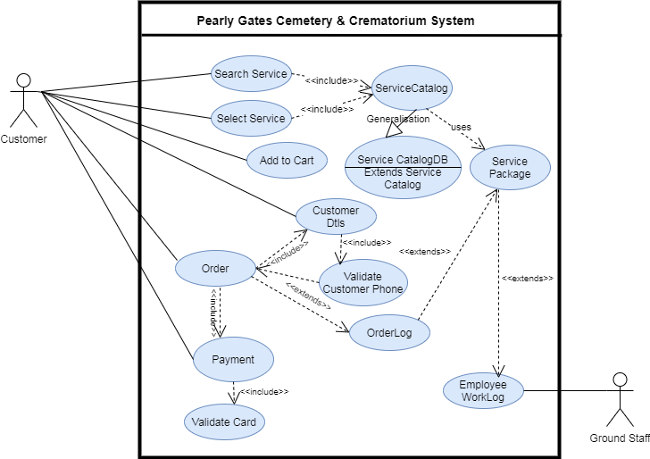

* 1. **USE CASE DESCRIPTION**

Use Case 1. Search and Select a Service

|  |  |  |
| --- | --- | --- |
| Use case # | 1 | |
| Use case name | Search and Select a Service | |
| Brief description | Customer selects a service from the one's showcased on the Pearly Gates web portal | |
| Related use cases | Cart , Service Catalog | |
| Entry conditions | Customer access Pearly Gates web portal | |
| Exit conditions | All services selected by Customer are added to the cart | |
| Flow of events | 1) | Customer access Pearly Gates Webpage showcasing all the services offered |
| 2) | Customer browse through the list of services offered |
| 3) | Customer selects services as per their requirements |
| 4) | Customer is shown the specifics and avaibility of the service selected |
| 5) | Customer selects the service slot/type of their choice |
| 6) | Selected service is added to the cart |
| Exception conditions | 1) | Phone number validation fails hence the workflow is routed back to customer details screen |
| 2) | Card validation fails, the workflow is routed back to order page |

Use Case 2. Cart

|  |  |  |
| --- | --- | --- |
| Use case # | 2 | |
| Use case name | Cart | |
| Brief description | Customer adds and checks the selected services | |
| Related use cases | Order | |
| Entry conditions | Customer adds selected services to cart | |
| Exit conditions | Customer Orders selected services | |
| Flow of events | 1) | Customer adds selected service to cart |
| 2) | Cart suggest related services to customer |
| 3) | Customer continues to browse the Pearly Gates webportal and select more services for addition to cart |
| 4) | Customer checks list of services selected and added to the cart, cart displays all the services added by the customer |
| 5) | Customer reviews the cart and adds or removes the services selected |
| 6) | Cart is updated based on the customer action |
| 7) | Client proceeds to Order, upon which the services in cart moves to order module and cart is emptied |
| Exception conditions | 1) | Incase customer cancels order selected services moves back to cart |
|  |  |

Use Case 3. Order

|  |  |  |
| --- | --- | --- |
| Use case # | 3 | |
| Use case name | Order | |
| Brief description | Customer Orders the selected services in the Cart | |
| Related use cases | Customer Details, Payment, Order Log | |
| Entry conditions | Customer orders the selected services in the Cart | |
| Exit conditions | 1) Order details flows into Order log 2) Order is cancelled and service details in Order moves back to Cart 3) Order remains in unsuccessful status as a result of Payment failure | |
| Flow of events | 1) | Customer selects Order |
| 2) | Selected services from Cart moves to Order |
| 3) | Customer is prompted to enter Customer Name and Phone |
| 4) | Customer enters customer name and phone number |
| 5) | Customer phone number is validated |
| 6) | Customer sees the invoice, showcasing list of services, cost of each service and total cost along with customer details |
| 7) | Customer selects "Next" or "Back" |
| 8) | If Customer selects "Back" customer moves back to cart where they can add or remove services |
| 9) | If Customer selects "Next" |
| 10) | Phone number validation is carried out via sending SMS |
| 11) | If validation fails Customer is routed back to customer details page |
| 12) | If validation is successful Order is processed to generate invoice |
| 13) | Customer reviews the invoice showcasing list of services selected and total payment due |
| 14) | Customer has the option to proceed to make payment or make changes to the order |
| 15) | Upon successful Payment, Order is confirmed to Customer and logged in Order Log |
| 16) | If customer cancels the order the services selected moves back to Cart |
| 17) | If Payment is unsuccessful the order status is updated as "Fail" |
|  |  |
| Exception conditions | 1) | Phone number validation fails hence the workflow is routed back to customer details screen |
| 2) | Card validation fails, the workflow is routed back to Order page |

Use Case 4. Payment

|  |  |  |
| --- | --- | --- |
| Use case # | 4 | |
| Use case name | Payment | |
| Brief description | Customer selects Payment option | |
| Related use cases | Validate Card, Order | |
| Entry conditions | Customer selects Payment option for their Order upon review of Invoice | |
| Exit conditions | Payment Success or Failure message sent to Order | |
| Flow of events | 1) | Customer selects Payment option |
| 2) | Customer is prompted to select payment mode i.e. Credit Card or Debit Card |
| 3) | Customer confirms payment mode |
| 4) | Customer is taken to payment page to enter card details |
| 5) | Customer enters card details and selects "Done" or "Cancel" |
| 6) | If "Cancel" is selected, customer is routed back to Order page |
| 7) | If "Done" is selected customer payment is processed |
| 8) | Transaction id generated for the payment is returned to the Order module |
| 9) | Based on the message received from Payment module, Order status is set to Success or Failed |
| 10) | User is shown Payment Confirmation message |
| 11) | User is shown Order confirmation message |
|  |  |
| Exception conditions | 1) | Phone number validation fails hence the workflow is routed back to customer details screen |
| 2) | Card validation fails, the workflow is routed back to Order page |

Use Case 5. Order Log

|  |  |  |
| --- | --- | --- |
| Use case # | 5 | |
| Use case name | Order Log, Service Catalog and Employee work log | |
| Brief description | Order Log is updated with Order details with status marked as "Success" | |
| Related use cases | Employee Work log, Order | |
| Entry conditions | Order status is marked as "Success" upon Payment | |
| Exit conditions | Employee work log is updated | |
| Flow of events | 1) | If Order status is "Success" order record is passed to Order log |
| 2) | Order log pass the details of order to service manager package |
| 3) | Based on the services in the Order record respective service module is updated for the respective service booking slot |
| 4) | Service booking confirmation flows to Employee work log |
| 5) | Employee work log generates service roster for the ground staff of Pearly Gates |
| 6) | Pearly Gates ground staff arrange for the services based on the daily service roster and Pearly Gates business process |
|  |  |

1. **CLASS DIAGRAM**

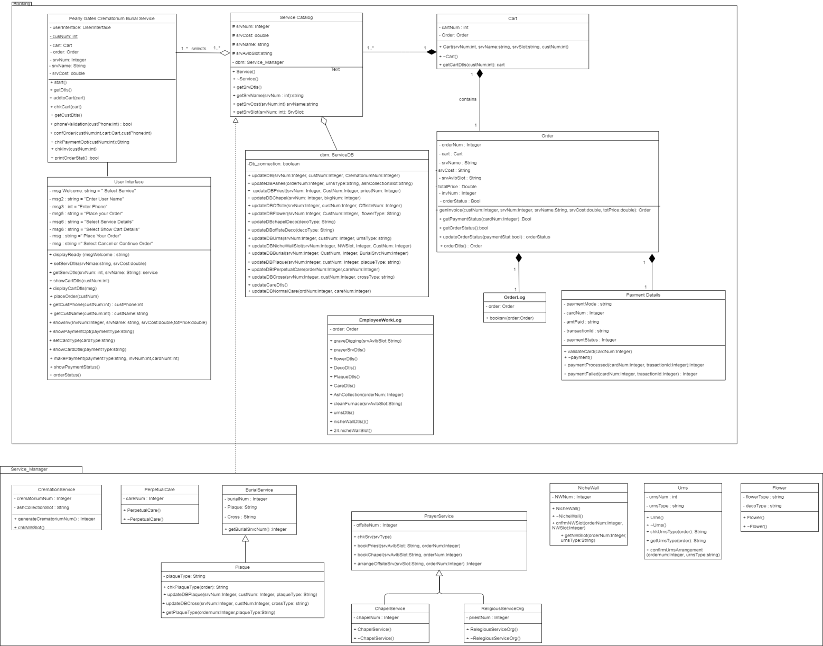

1. **SEQUENCE DIAGRAM**
   1. **Booking Sequence**

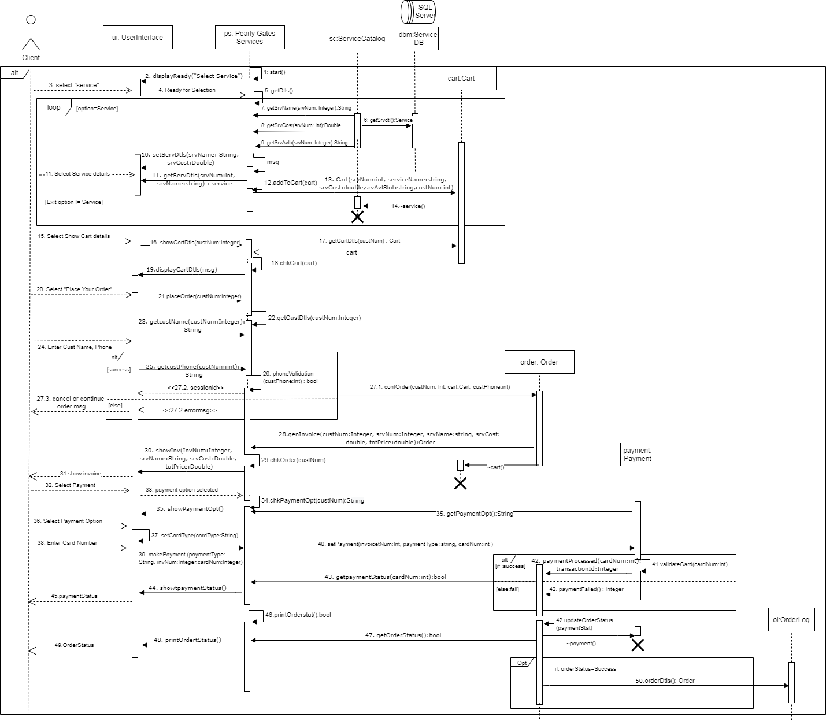

**b. Crematorium and Related Service Package Flow (post successful booking)**

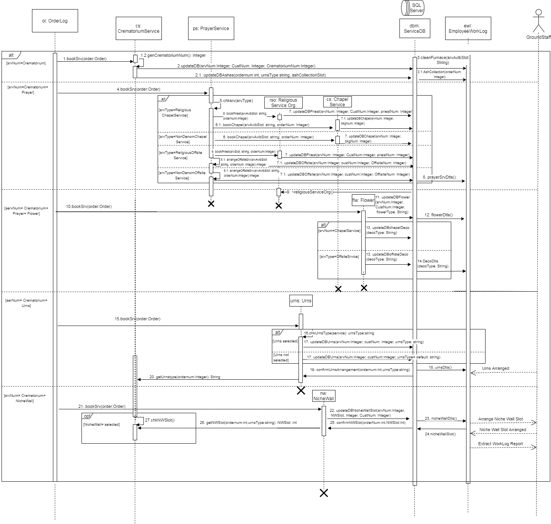

**c. Burial and Related Service Package Flow (post successful booking)**

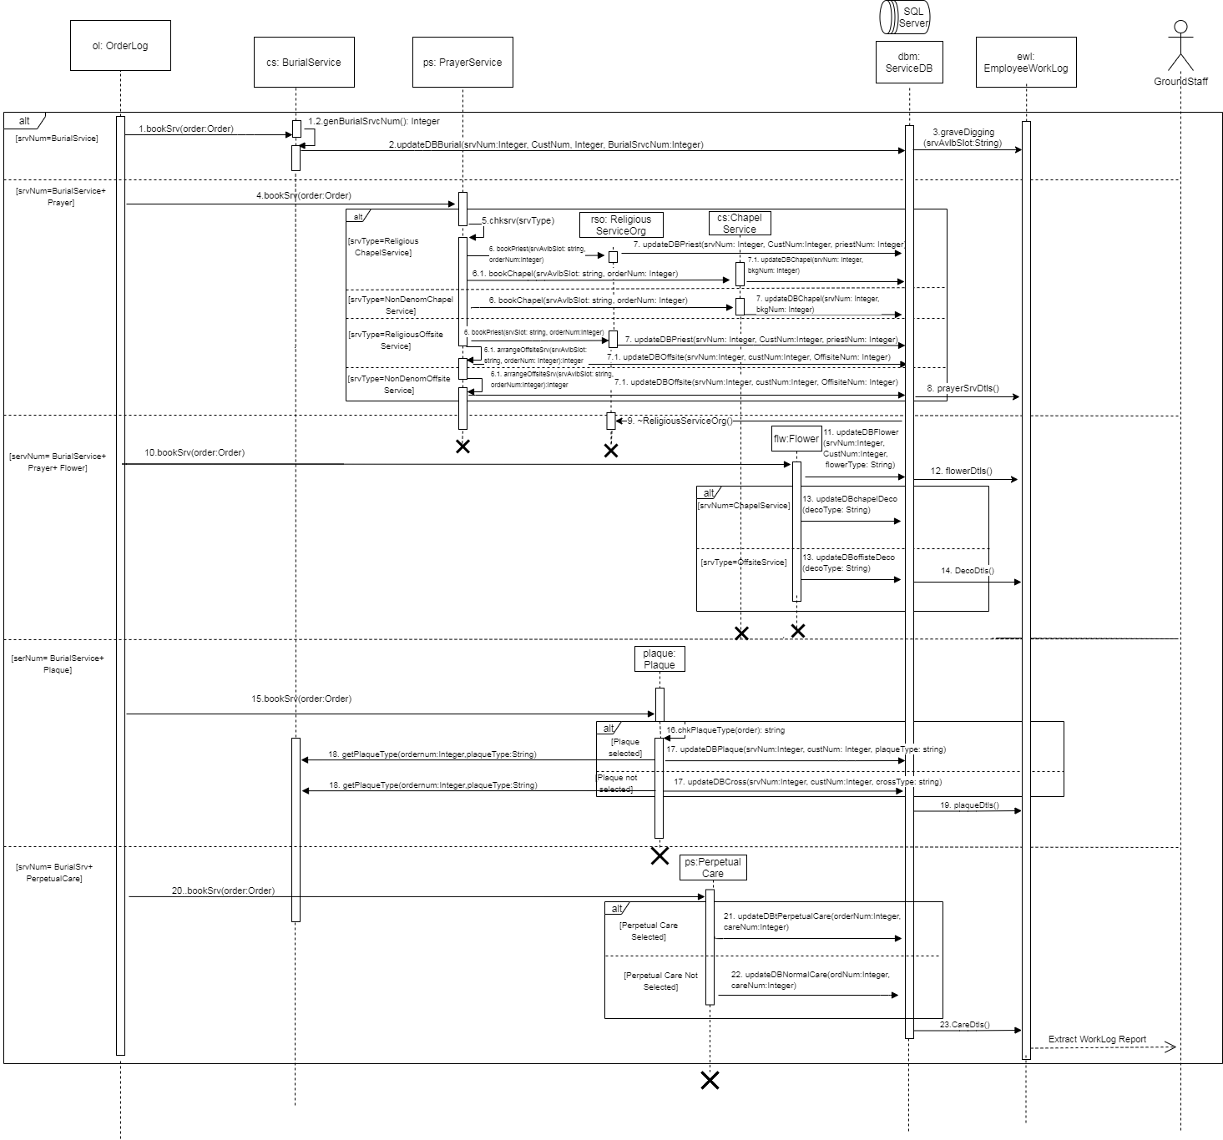

**d. Memorial Service**

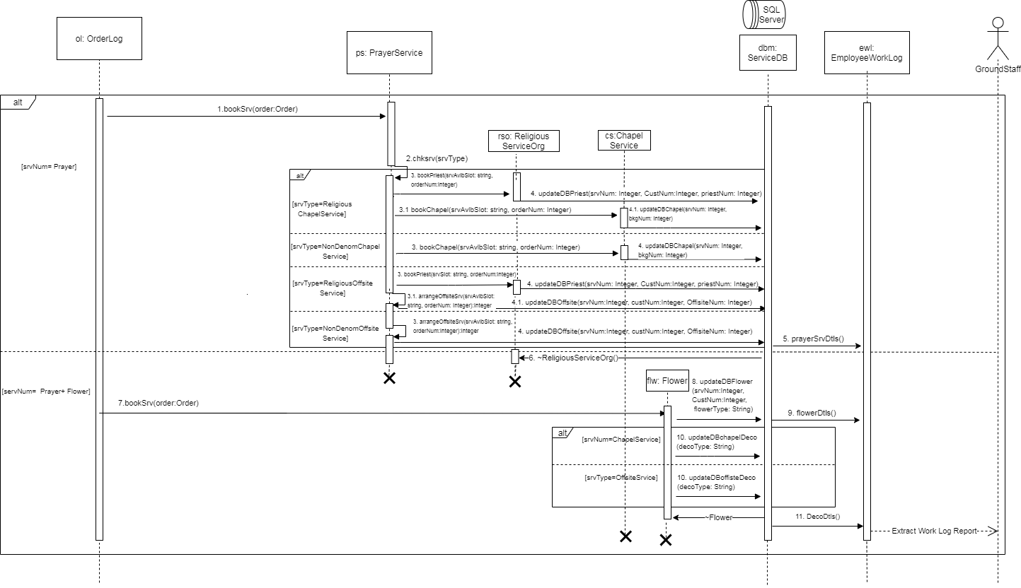

1. **SYSTEM ARCHITECTURE AND DEPLOYMENT STRATEGY:**
   1. **System Architecture:**

Pearly Gates software uses layered architecture; external customer is able to access Pearly Gates web portal via Mobile and Computer. Pearly Gates Webserver interacts with the application layer; this intern interacts with database server residing on operating system server.

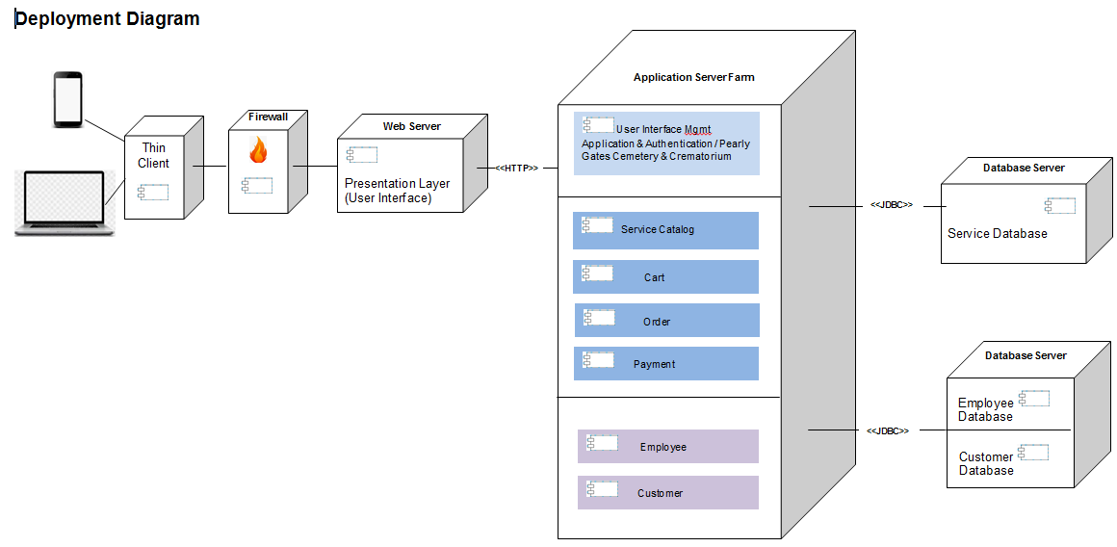

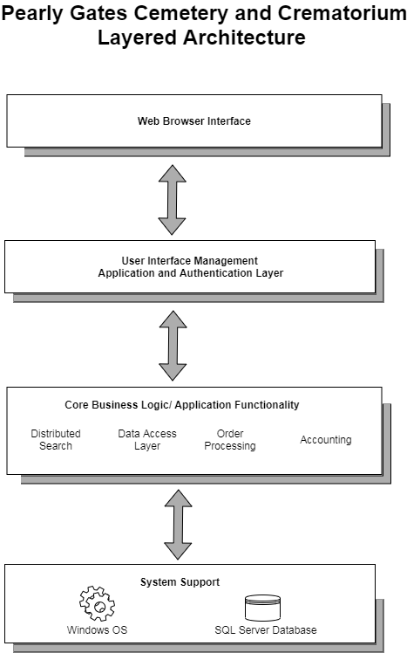

* 1. **Deployment Strategy**

A Parallel Deployment approach is implemented wherein; web portal is available to users for booking of services offered by Pearly Gates. However users may also select the legacy system of manual booking of services via calling the office staff.

The 4 weeks of parallel operations provides Pearly Gates time to assess the stability and reliability of the new system and build confidence in the staff and external customers on the operational aspect of the new system thus minimising the risk of disruption to Pearly Gates services during the transition phase. At the end of 4 weeks the manual service booking system is phased out.

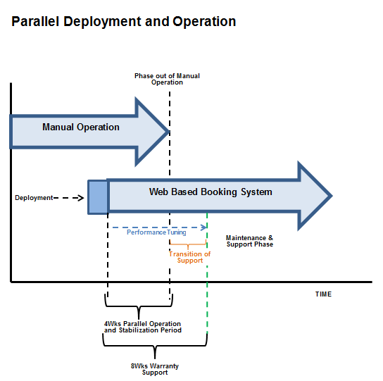

Project team is planned to provide 8 weeks of warranty support to ensure knowledge transition to Pearly Gates IT Support team. The transition is planned in 2 phases. During phase1, project team leads all aspects of maintenance and support while Pearly Gates IT support shadows the project team. In phase-2, the Pearly Gates IT support takes the lead while the project team continues to shadow support and guide the Pearly Gates IT support staff.

1. **USER INTERFACE**

A user friendly interface is designed for ease of operations and accessibility

|  |  |
| --- | --- |
| * 1. Home page: allows user to see the services offered by Pearly Gates and select services | * 1. Service page: offers details of service (such as date/time of cremation) selected by the customer |
|  |  |
| * 1. Cart: Details of selected services are added to the Cart and customer is offered the choice to view Cart, add/remove services from cart and move to Order option | * 1. Customer Info: Upon clicking Order user is asked to enter customer details |
|  |  |
| * 1. Invoice: Upon validation of customer details, Invoice is shown to the user with details of services selected and total price | * 1. Payment Gateway: Once user confirms to pay, payment options are shown, and payment details are collected |
|  |  |

1. **MEETING DETAILS**

Minutes of meeting #9

**Group -** Thunder Cougar Falcon Bird

**Place -** Zoom

**Date/Time –** 5/06/2020 11:00

**In attendance**

Caleb, Nathaniel, Anand

**Absent**

Akshata

**Agenda**

1. Review user interface
2. Review deployment strategy

**Action sheet**

|  |  |  |  |
| --- | --- | --- | --- |
| **#** | **Key Areas** | **Action Required/ Date** | **Action Owner** |
| 1. | User Interface descriptions | Typed out by reviewing Ui | Nathaniel |
| 2. | Review of deployment strategy. Agreed to use the version as the final one. | No action required. |  |
| 3 | Collate all the material required for the assignment | Share the collated material for review on the formatting. | Akshata and Caleb |
| 4 | Preparing the report | Combining all the different sections and formatting the report according to the guidelines. | Nathaniel and Anand |
| 5 | Review of the final report | No action required. | Akshata, Caleb, Nathaniel and Anand |

**Next Meeting** – Monday 04.06.2020 14:00

* Review and finalise the report

Minutes of meeting #8

**Group -** Thunder Cougar Falcon Bird

**Place -** Zoom

**Date/Time –** 2/06/2020 13:00

**In attendance**

Caleb, Akshata

**Absent**

Anand, Nathaniel

**Agenda**

1. Review Class diagram and Sequence diagram
2. Review user interface

**Action sheet**

|  |  |  |  |
| --- | --- | --- | --- |
| **#** | **Key Areas** | **Action Required/ Date** | **Action Owner** |
| 1. | Both Booking and Service Manager package class diagram were reviewed alongside the 4 sequence diagram, final updates and fine-tuning of sequence diagram | Update sequence diagram based on the discussion by 3rd June | Akshata |
| 2. | User interface shared by Akshata was discussed, Caleb suggested to have a finer version developed | Finalise user interface by 3rd June | Caleb |
| 3. | Discussed deployment strategy with the focus to ensure a seamless transition of service, with no disruptions so that customers are not impacted. | Prepare write-up on deployment strategy | Akshata |

**Next Meeting** – Monday 3.06.2020 14:00

* Review user interface
* Review deployment strategy

Minutes of meeting #7

**Group -** Thunder Cougar Falcon Bird

**Place -** Zoom

**Date/Time –** 2/06/2020 10:00

**In attendance**

Caleb, Akshata

**Absent**

Anand, Nathaniel

**Agenda**

1. Finalise the booking package class diagram
2. Review the service manager package class diagram
3. Review the sequence diagram

**Action sheet**

|  |  |  |  |
| --- | --- | --- | --- |
| **#** | **Key Areas** | **Action Required/ Date** | **Action Owner** |
| 1. | * Booking package Class diagram was discussed and agreed to be used as final version * Updates discussed to service manager package to have plaque added as a child class of burial class * Attributes and functions of service package discussed in detail | Update service package class diagram and share the final copy | Caleb |
| 2. | * Sequence diagram for booking flow is finalised. * Agreed to have 3 more sequence diagram to depict the system flow for each set of service | Draw sequence diagram based on the class diagram shared for the 3 service flows | Akshata |
| 3. | Discussed interface layout for the use case | Draw and share draft version of user interface | Akshata |

**Next Meeting** – Monday 1.06.2020 14:00

* Review Class diagram and Sequence diagram
* Review user interface

Minutes of meeting #6

**Group -** Thunder Cougar Falcon Bird

**Place -** Zoom

**Date/Time –** 31/05/2020 13:00

**In attendance**

Caleb, Akshata

**Absent**

Anand, Nathaniel

**Agenda**

1. Review the class diagram
2. Discuss the sequence diagram

**Action sheet**

|  |  |  |  |
| --- | --- | --- | --- |
| **#** | **Key Areas** | **Action Required/ Date** | **Action Owner** |
| 1. | Class diagram reviewed. Updates discussed to the attributes and functions of both booking and service manager package | Updates discussed to the attributes and functions to be shared for classes in the booking package by 23rd May  Updates discussed to the attributes and function of service manager package to incorporated in the class diagram and shared by 27th May | Caleb |
| 2. | Use the functions listed in the booking class diagram and incorporate in the sequence diagram flow.  Discussed the information flow for post booking | Share the updated sequence diagram flow for booking system by 27th May  Share a rough draft of sequence diagram on the post booking flow of information | Akshata |

**Next Meeting** – Thursday 28.05.2020 14:00

* Finalise the booking package class diagram
* Review the service manager package class diagram
* Review the sequence diagram

Minutes of meeting #5

**Group -** Thunder Cougar Falcon Bird

**Place -** Zoom

**Date/Time –** 27/05/2020 13:00

**In attendance**

Caleb, Akshata

**Absent**

Anand, Nathaniel

**Agenda**

1. Review the class diagram
2. Discuss the sequence diagram

**Action sheet**

|  |  |  |  |
| --- | --- | --- | --- |
| **#** | **Key Areas** | **Action Required/ Date** | **Action Owner** |
| 1. | Review comments shared on the class diagram were discussed, relationships between the classes was identified.  Agreed to have a unique id for every customer accessing the web portal. Discussion on the class ownership for generation of unique id.  Add attributes and functions to the class diagram | Based on the discussion update the class diagram, 20th May | Caleb |
| 2. | Rough draft of sequence diagram discussed  In-order to keep the system simple it was agreed that customers should be able to book services without having to login or register on the portal however a authentication of the customer is required, both members agreed to have authentication based on mobile number shared by the client  In order to keep the system flow simple and easy to use it was agreed that only available slot of services to be shown and shared with the customer | Based on the discussion update the sequence diagram by 20th May | Akshata |

**Next Meeting** – Thursday 21.05.2020 14:00

* Review the class diagram
* Review the sequence diagram

Minutes of meeting #4

**Group -** Thunder Cougar Falcon Bird

**Place -** Zoom

**Date/Time –** 23/05/2020 13:00

**In attendance**

Caleb, Akshata

**Absent**

Anand, Nathaniel

**Agenda**

1. Review the system setup diagram
2. Refine the class diagram
3. Discuss Sequence diagram

**Action sheet**

|  |  |  |  |
| --- | --- | --- | --- |
| **#** | **Key Areas** | **Action Required/ Date** | **Action Owner** |
| 1. | Review of the system setup diagram was carried out, it was agreed to have thin client before the firewall | Changes to be made to system setup diagram and share by 11th May | Akshata |
| 2. | Rough draft of class diagram was discussed in details, agreed to have service as separate package.  Agreed to have serviceDB class added and controlling information flow via Pearly Gates application class | Refine the class diagram, add attributes and functions to the classes be shared by 10th May | Caleb |
| 2. | Discussion on the sequence diagram and the number of sequence diagrams required | Prepare a rough draft of sequence diagram flow as per the use case diagram and share by 11th May | Akshata |

**Next Meeting** – Thursday 14.05.2020 14:00

* Review the class diagram
* Discuss the sequence diagram

Minutes of meeting #3

**Group -** Thunder Cougar Falcon Bird

**Place -** Zoom

**Date/Time –** 11/05/2020 13:00

**In attendance**

Caleb, Akshata

**Absent**

Anand, Nathaniel

**Agenda**

1. Review the use case diagram
2. Review use case descriptions and write-up
3. Review system architecture layout
4. Share understanding and approach on class diagram
5. Identify next steps and task owners

**Action sheet**

|  |  |  |  |
| --- | --- | --- | --- |
| **#** | **Key Areas** | **Action Required/ Date** | **Action Owner** |
| 1. | Use case diagram discussed and reviewed. | Changes discussed to be incorporated in the diagram by 2nd May | Caleb |
| 2. | Use case descriptions and write-up reviewed | Changes discussed to be incorporated in the description and write-up by 2nd May | Akshata |
| 2. | System Architecture diagram reviewed in-context to the system setup required. | Prepare System Setup diagram | Akshata |
| 3. | Discussed the list of classes, relationships, attributes and functions | Based on the discussion, create a rough view of Class Diagram and share prior to next meeting | Akshata |

**Next Meeting** – Thursday 7.05.2020 14:00

* Review the system setup diagram
* Refine the class diagram
* Discuss Sequence diagram

Minutes of meeting #2

**Group -** Thunder Cougar Falcon Bird

**Place -** Zoom

**Date/Time –** 2/05/2020 13:00

**In attendance**

Caleb, Akshata

**Absent**

Anand, Nathaniel

**Agenda**

1. Review the use case list
2. Review System flow and setup
3. Share understanding and approach on class diagram
4. Identify next steps and task owners

**Action sheet**

|  |  |  |  |
| --- | --- | --- | --- |
| **#** | **Key Areas** | **Action Required/ Date** | **Action Owner** |
| 1. | Details shared on the response for number of use cases as received via discussion forum. Outline of use case agreed. |  | Akshata |
| 2. | Review of use case list | a. Draw use case diagram by 27th Apr  b. Prepare write-up on use case list and use case descriptions by 27th Apr | Caleb  Akshata |
| 2. | Review of System flow and Setup. Discussed pros and cons of various architecture and reached an agreement on using Layered Architecture | Draw System Architecture and share by 27th Apr | Akshata |
| 3. | Discussed the approach for developing class diagram, both members agreed to read through the chapter 4 and 5, learnings to be shared in next meeting in context to the case study | Read through chapter 4 and 5 | Caleb and Akshata |

**Next Meeting** – Thursday 30.04.2020 14:00

* Review the use case diagram and use case descriptions
* Discuss and plan number of classes in the class diagram
* Share ideas on the attributes and functions within class diagram

Minutes of meeting #1

**Group -** Thunder Cougar Falcon Bird

**Place -** Zoom

**Date/Time –** 29/04/2020 14:00

**In attendance**

Caleb, Akshata

**Absent**

Anand, Nathaniel

**Agenda**

1. Discuss the scope of the assignment. Work through the idea of being in the solution space as opposed to the problem space.
2. Major functions performed by the system, in-scope functions and functions performed by the staff.
3. Plan basic structure of system including how a user would interact with the system.
4. Schedule next meetings, agree on the date and time
5. Meeting notes ownership

**Action sheet**

|  |  |  |  |
| --- | --- | --- | --- |
| **#** | **Key Areas** | **Action Required** | **Action Owner** |
| 1. | Discussed case study and understanding on the use case task. Agreed to seek further clarity on the number of use cases for the assignment | Seek clarity on the number of use cases required | Akshata |
| 2. | Discussed the approach for developing class diagram, both members agreed to read through the chapter 4 and 5, learnings to be shared in next meeting | Read through chapter 4 and 5 | Caleb and Akshata |
| 3. | Both members agreed to seek feedback on Assignment 1, so that the feedback can be incorporated in Assignment 2 | Request feedback on Assignment1 | Akshata |
| 4. | Discussion on System Flow Diagram | a. Create system flow diagram and share before next meeting  b. Create and Share list of use cases before next meeting | Akshata  Caleb |
| 5. | a. Agreement on the meeting schedule and time  b. Meeting notes ownership, Caleb agreed to take ownership of taking meeting notes and sharing it on the same day of the meeting |  | Caleb & Akshata  Caleb |

**Next Meeting** – Thursday 22.04.2020 13:00

* Review the use case list
* Review system flow and setup
* Identify next steps and task owners

**7.** **REFERENCES**

1. <http://www.w3schools.com/>
2. <http://agilemodeling.com/>
3. [https://en.wikipedia.org/wiki/Class_diagram#](https://en.wikipedia.org/wiki/Class_diagram)
4. <http://www.tracemodeler.com/articles/a_quick_introduction_to_uml_sequence_diagrams/>
5. <https://www.uml-diagrams.org/sequence-diagrams.html>

**8. TOOLS USED**

* Draw.io
* MS Office Suite
* Lucid Chart
* Zoom